Assignment 2 Report: MNIST Digit Classification using CNN
Mohsin Hussain Shaik
Date : 10-04-2026
Topic: Convolutional Neural Network (CNN) (Deep Learning)
1. Project Objective
The goal of this assignment was to design and train a Convolutional Neural Network (CNN) capable of recognizing handwritten digits. Beyond just training on a standard dataset, the project involved testing the model's "real-world" performance using custom-drawn images to see how well the features generalized outside the training environment.
2. Dataset Overview
I used the MNIST dataset, which is the industry standard for starting with computer vision.
- Content: 70,000 grayscale images (28x28 pixels).
- Classes: 10 (Digits 0 through 9).
- Split: 60,000 for training and 10,000 for testing.
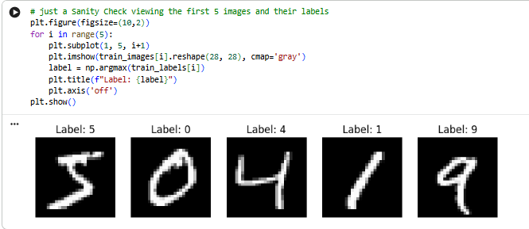

3. Data Preprocessing
Raw data isn't ready for a neural network immediately. I performed the following steps:
- Reshaping: Converted the images from (28, 28) to (28, 28, 1). The extra dimension represents the single colour channel (grayscale), which the Conv2D layers require.
- Normalization: Scaled pixel values from [0, 255] down to [0, 1] by dividing by 255. Just to prevent large gradients from slowing down the learning process.
- Label Encoding: Used One-Hot Encoding so the model treats labels as categories rather than a continuous range of numbers.
4. Model Architecture
I built a Sequential CNN with the following layers:
- Convolutional Layers: Used three layers with ReLU activation to detect edges, curves, and eventually whole digit shapes.
- Max Pooling: Added after the first two Conv layers to reduce spatial dimensions and make the model more robust to the exact position of the digit.
- Dropout (0.5): This was a key step. By randomly "killing" 50% of neurons during training, I forced the model to learn redundant patterns, which helps prevent overfitting.
- Softmax Output: The final 10-neuron layer provides a probability distribution for each digit class.
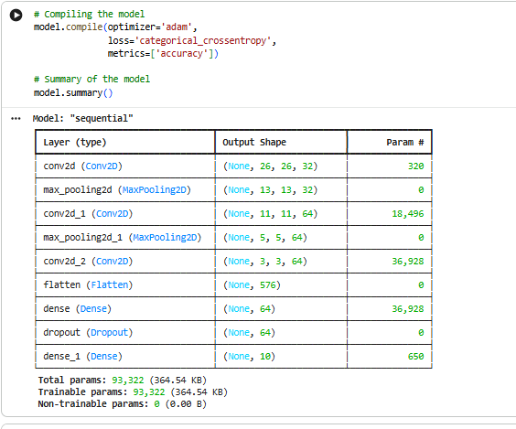
5. Training and Performance
I trained the model for 10 epochs using the Adam optimizer and Categorical Crossentropy loss.
- Training Observations: The model converged very quickly. By Epoch 2, accuracy was already above 96%.
- Validation: I used a 10% validation split. The final validation accuracy hovered around 99.2%, showing no significant signs of overfitting.
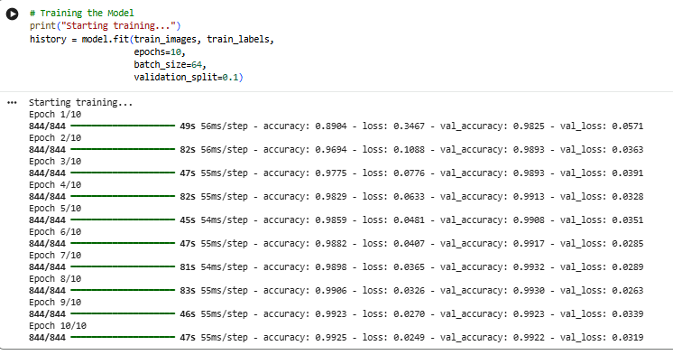
6. Final Evaluation
On the final "hidden" test set (images the model never saw during training), the results were:
- Test Accuracy: 99.15%
- Test Loss: 0.0323
This confirms the model is highly reliable.
7. Custom Image Testing
I tested the model using my own handwritten digits & paint images.
- Process: I uploaded custom images, inverted the colours (to match MNIST's white-on-black style), and resized them to 28x28.
- Result: So out of 12 images 10 images were Correctly identified 2 images which were handwritten with light stroke pen were wrongly identified (The thickness of text is also quite important here)
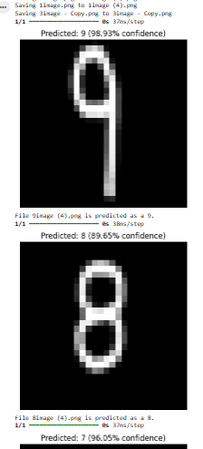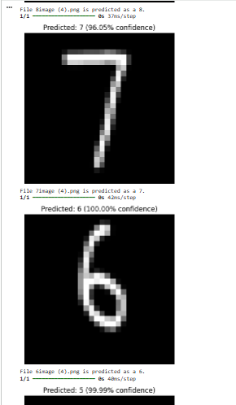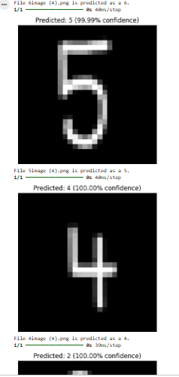

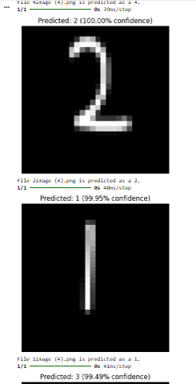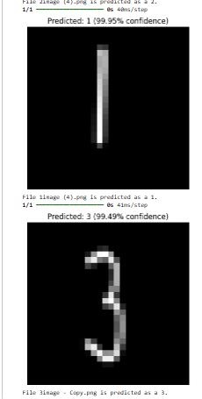

When tested with a light marker pen the predictions were wrong
Interestingly, when testing the model with a light marker pen, the predictions were consistently incorrect. For example, a hand-drawn 4 was predicted as a 1. This highlights a limitation of the model's preprocessing pipeline: thin, light strokes lose their structural integrity when down sampled to a 28x28 resolution.
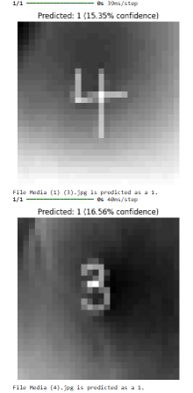

8. Conclusion
This project demonstrates that CNNs are incredibly effective at spatial pattern recognition. The high test accuracy (99.15%) shows that the combination of convolutional filtering and dropout regularization creates a model that doesn't just memorize data but understands the geometry of numbers. For future improvements, I could experiment with data augmentation (rotating/shifting images) to make the model even more robust to messy handwriting.

